# ACTIVITY-1

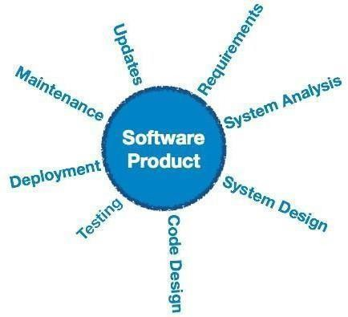

## Software engineering

Software engineering is a systematic engineering approach to software development. A software engineer is a person who applies the principles of software engineering to design, develop, maintain, test, and evaluate computer software.

**Software engineering** is the systematic application of engineering principles to the design, development, maintenance, testing, and evaluation of software and systems.

It involves using a **structured and methodical approach** to software creation, focusing on best practices, quality assurance, and efficient management of resources to build reliable and scalable software solutions.

### Key Concepts in Software Engineering:

1. **Software Development Life Cycle (SDLC)**: This is the process of planning, creating, testing, and deploying software. Common stages in SDLC include:
   * **Requirement Gathering & Analysis**: Understanding what the user needs and defining clear and concise requirements.
   * **Design**: Creating the architecture and design for the software.
   * **Implementation (Coding)**: Writing the actual code based on the design.
   * **Testing**: Checking if the software works as expected and meets the requirements.
   * **Deployment**: Releasing the software for use.
   * **Maintenance**: Ongoing support and updates after the software is deployed.
2. **Software Design Patterns**: These are typical solutions to common design problems. Examples include:
   * **Singleton**: Ensures a class has only one instance.
   * **Factory**: Creates objects without specifying the exact class of the object that will be created.
   * **Observer**: Defines a one-to-many dependency between objects.
3. **Version Control**: Using tools like Git to track changes to code over time, allowing multiple developers to collaborate, and easily revert to previous versions of software.

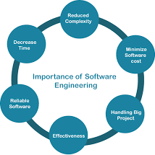

1. **Testing & Debugging**: Ensuring the software behaves correctly through:

* **Unit Testing**: Testing individual parts of the software.
* **Integration Testing**: Testing if different components work together.
* **System Testing**: Testing the whole system to ensure it meets requirements.
* **User Acceptance Testing (UAT)**: Ensuring that the software meets user needs.

1. **Agile Methodologies**: A flexible, iterative approach to software development that values customer collaboration and responsiveness to change. Common agile frameworks include:

* **Scrum**: Uses sprints (short development cycles) to release small, incremental improvements to the software.
* **Kanban**: Focuses on visualizing work and improving efficiency through continuous delivery.

1. **Software Architecture**: The high-level structure of the software, including the organization of components and how they interact. Common architectures include:

* **Monolithic Architecture**: The software is built as a single, large unit.
* **Microservices Architecture**: The software is split into smaller, independently deployable services.

1. **Security in Software Engineering**: Ensuring that software is resistant to malicious attacks and vulnerabilities. This includes practices like:

* **Encryption**: Protecting data by converting it into a secure format.
* **Authentication & Authorization**: Verifying user identity and permissions.
* **Penetration Testing**: Simulating attacks to find weaknesses in the system.

#### Tools & Technologies in Software Engineering:

* **Integrated Development Environments (IDEs)**: Tools like Visual Studio Code, IntelliJ IDEA, Eclipse.
* **Database Management Systems (DBMS)**: MySQL, PostgreSQL, Oracle, MongoDB.
* **Project Management Tools**: Jira, Asana, Trello.
* **Collaboration Tools**: GitHub, GitLab, Bitbucket.
* **Containerization & Virtualization**: Docker, Kubernetes, Vagrant.

**Activity-2**

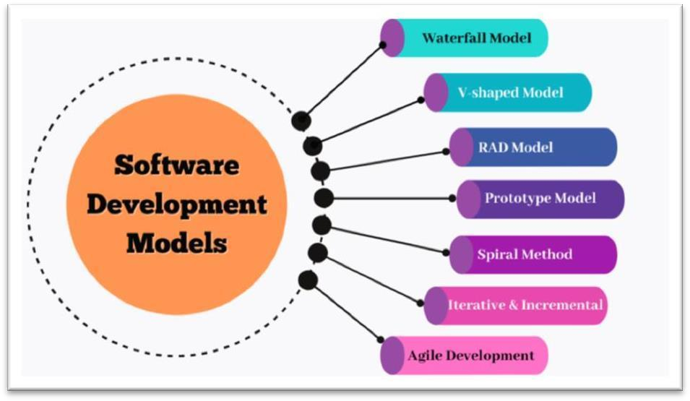

**Software Process Model**

A **software process model** is a structured approach or methodology used to manage and guide the software development process. It defines the phases, tasks, and activities that must be performed during the development of software, ensuring that the software is built effectively and efficiently. There are various software process models, each with its unique approach to organizing and executing the development lifecycle.

### Common Software Process Models:

#### Waterfall Model

Description: The Waterfall model is one of the earliest and simplest software development models. It is a linear and sequential process where each phase must be completed before moving to the next one**.** The phases in the Waterfall model are typically:

* + **Requirement Gathering**: Collecting and documenting requirements.
  + **System Design**: Creating the software architecture and design.
  + **Implementation (Coding)**: Writing the code based on the design.
  + **Testing**: Verifying that the software functions as expected.
  + **Deployment**: Releasing the software to users.
  + **Maintenance**: Ongoing support and updates.

**Advantages**: Simple and easy to understand; clear documentation at each phase. **Disadvantages**: Rigid, with little room for changes; difficult to go back and make changes after a phase is completed.

#### 2.V-Model (Verification and Validation Model):

**Description**: The V-Model is an extension of the Waterfall model where development and testing are closely aligned. It focuses on **verification** (building the product right) and **validation** (building the right product) through parallel stages of development and testing.

#### Phases:

* + **Requirement Analysis**: Define requirements.
  + **System Design**: Develop the architecture and design.
  + **Implementation**: Write the code.
  + **Unit Testing**: Test individual components.
  + **Integration Testing**: Test interaction between components.
  + **System Testing**: Test the entire system.
  + **Acceptance Testing**: Test with the user.

**Advantages**: Early test planning and more structured testing activities.

**Disadvantages**: Like Waterfall, it's not flexible and is difficult to adapt if requirements change.

#### Incremental Model:

**Description**: The Incremental model breaks the software development process into smaller, **manageable portions**, or **increments**. Each increment builds on the previous one and provides a working part of the software after every iteration. It allows for partial implementation of functionality early in the process.

The phases (like requirements, design, implementation, and testing) are repeated for each increment.

**Advantages**: Flexibility in handling changes; functionality is delivered earlier, and feedback can be incorporated after each increment.

**Disadvantages**: Can lead to integration challenges as the system evolves incrementally.

#### Spiral Model:

**Description**: The Spiral model combines elements of both iterative and Waterfall models. It divides the software development process into **repetitive cycles (spirals)**, each including planning, risk analysis, engineering, testing, and evaluation. Each cycle produces a working prototype and allows for feedback.

The main phases of the Spiral model include:

* + **Planning**: Define goals and objectives for the project.
  + **Risk Analysis**: Identify and mitigate risks.
  + **Engineering**: Design and implement.
  + **Testing and Evaluation**: Review progress and adjust plan

**Advantages**: High emphasis on risk management and early identification of problems; continuous feedback and improvement

**Disadvantages**: Can be complex and costly; requires careful planning and management.

#### Agile Model

**Description**: The Agile model is a **flexible and iterative** approach focused on delivering small, **incremental updates** to the software with regular customer feedback. Agile emphasizes collaboration, customer involvement, and adaptability. It works in short cycles known as **sprints** (usually 1 to 4 weeks), where a small, working piece of functionality is delivered.

#### Key practices in Agile include:

* + **User Stories**: Descriptions of software functionality from the user's perspective.
  + **Scrum**: A framework for managing sprints and team collaboration.
  + **Continuous Integration and Testing**: Ensuring code is integrated and tested frequently.

**Advantages**: Flexibility to respond to changes in requirements; faster delivery of working software.

**Disadvantages**: Requires strong communication and team collaboration; scope creep can occur if requirements are not well managed.

#### RAD Model (Rapid Application Development):

**Description**: The RAD model focuses on rapid prototyping and user feedback. It is an **iterative** model that emphasizes speed and efficiency. The goal is to quickly develop functional prototypes and iterate based on user feedback, significantly reducing the time needed for the development process.

#### Phases in RAD:

* + **Requirement Planning**: Define core requirements.
  + **User Design**: Create prototypes and gather feedback.
  + **Construction**: Develop the software based on feedback.
  + **Cutover**: Finalize and deploy the system.

**Advantages**: Faster development process and quicker feedback from users.

**Disadvantages**: Can be difficult to scale for larger projects; prototyping may miss some functional requirements.

#### DevOps Model:

**Description**: DevOps is a culture and set of practices that integrate **development** (Dev) and **operations** (Ops) teams. It emphasizes automation, collaboration, and continuous delivery to accelerate the development, testing, and deployment process.

#### Key elements include

* + **Continuous Integration (CI)**: Developers frequently commit code to a shared repository.
  + **Continuous Delivery (CD)**: Automating the release process to deploy updates quickly.
  + **Monitoring and Feedback**: Real-time feedback loops from users and systems.

**Advantages**: Faster time-to-market; improved collaboration and communication between teams.

**Disadvantages**: Requires a cultural shift; can be challenging to implement in large organizations.

#### Applications of Software Process Models

Software process models are applied in various domains to ensure efficient, structured, and high- quality software development. The choice of the right model depends on the nature of the project, team dynamics, and customer requirements. Below are key applications of software process models:

#### Application in Different Domains

* 1. **Business and Enterprise Software Development**
     + **Model Used:** Agile, DevOps, Incremental

#### Application:

* + - * Development of **ERP (Enterprise Resource Planning)** and **CRM (Customer Relationship Management)** systems.
      * Frequent updates and improvements to **business intelligence** tools.
      * Rapid deployment of **cloud-based business applications**.

#### Web and Mobile App Development

* + - **Model Used:** Agile, Incremental, Prototype

#### Application:

* + - * Developing **e-commerce platforms, social media apps, and SaaS applications**.
      * Continuous iterations and user feedback-based improvements.
      * Early release of MVP (Minimum Viable Product) for **market validation**.

#### Embedded Systems and IoT Development

* + - **Model Used:** V-Model, Spiral

#### Application:

* + - * Development of **real-time operating systems (RTOS)** for embedded devices.
      * Software for IoT-enabled **smart home devices, automotive control systems, and industrial automation**.
      * Ensures strict validation and safety compliance.

#### Healthcare and Medical Software

* + - **Model Used:** V-Model, Spiral

#### Application:

* + - * Development of **health monitoring applications, electronic health records (EHR), and medical imaging software**.
      * Ensures rigorous **regulatory compliance (FDA, HIPAA, IEC 62304)**.
      * Extensive validation and testing to avoid failures in **life-critical systems**.

#### Banking and Financial Applications

* + - **Model Used:** Waterfall, Spiral, Agile
    - **Application:**
      * Development of **secure banking applications, payment gateways, and fraud detection systems**.
      * Requires **strong security measures, compliance with financial regulations, and risk management**.
      * Uses iterative models to enhance **real-time transaction processing**.

#### Defense and Aerospace Software

* + - **Model Used:** Waterfall, V-Model, Spiral
    - **Application:**
      * Development of **flight control systems, missile guidance software, and military simulation programs**.
      * Requires **high reliability, real-time performance, and thorough verification**.
      * Uses **strict documentation and safety-critical system validation**.
  1. **Game Development**
     + **Model Used:** Agile, Prototype, Incremental

#### Application:

* + - * Development of **video games, VR/AR applications, and simulation software**.
      * Uses rapid prototyping to refine **graphics, physics, and gameplay mechanics**.
      * Iterative sprints help in **game balancing and bug fixes**.

#### Key Benefits of Applying Software Process Models

* + - Improves project predictability and planning
    - Enhances software quality and security
    - Reduces risk through iterative development
    - Ensures compliance with industry standards
    - Speeds up time-to-market for new products

#### Conclusion

Software process models are applied in almost every industry to **streamline development, manage risks, and ensure high-quality software**. Choosing the right model is crucial for project success, balancing flexibility, cost, and regulatory needs.Software process models are critical for **ensuring efficiency, quality, and risk management** in software development. The choice of a model depends on **project complexity, industry requirements, and customer needs**. Many organizations **combine multiple models** (e.g., Hybrid Agile-Waterfall) to maximize benefits.

# ACTIVITY-3

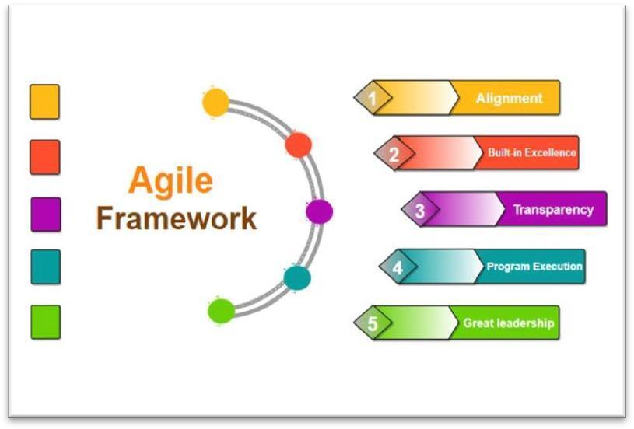

## Agile Framework

The **Agile framework** is a methodology primarily used in software development but is applicable to a variety of project management contexts. It emphasizes flexibility, collaboration, rapid delivery, and continuous improvement. Agile values customer collaboration over contract negotiation and responding to change over following a strict plan. Here are some key concepts and practices associated with Agile:

### Agile Principles

The Agile Manifesto outlines 12 principles that guide the framework:

* + **Customer satisfaction** through early and continuous delivery of valuable software.
  + Welcome **changing requirements**, even late in development.
  + **Deliver working software** frequently, with a preference for shorter timescales (e.g., weeks rather than months).
  + **Collaborate daily** with business stakeholders and developers.
  + **Support and trust** motivated individuals, providing them with the environment and tools needed to succeed.
  + **Face-to-face communication** is the most efficient way to convey information.
  + **Working software** is the primary measure of progress.
  + **Sustainable development**, maintaining a constant pace indefinitely.
  + Focus on **technical excellence** and good design.
  + **Simplicity**—the art of maximizing the amount of work not done.
  + **Self-organizing teams** are the best way to achieve the best architectures, requirements, and designs.
  + Regularly reflect on the process and adjust for improvement.

### Agile Frameworks

There are several frameworks that implement Agile principles, each with its unique approach:

**Scrum**: One of the most popular frameworks, focusing on structured cycles called "sprints" (typically 2-4 weeks). It includes roles like Scrum Master, Product Owner, and the development team.

* + **Sprints**: Short development cycles.
  + **Daily Standups**: Short meetings to track progress.
  + **Sprint Planning, Review, and Retrospective**: Structured events at the start and end of each sprint.

**Kanban**: Focuses on visualizing work, limiting work in progress, and optimizing flow. It doesn’t use sprints like Scrum, but instead, tasks move continuously through various stages.

* + **Work in Progress (WIP) limits**: Restricting how many tasks can be in progress at any one time.
  + **Continuous delivery**: Items are delivered as they are completed.

**Lean**: Focuses on reducing waste, improving quality, and optimizing the flow of value.

* + Emphasizes improving processes through continuous delivery and reducing unnecessary work.
  + **Extreme Programming (XP)**: Emphasizes technical excellence with practices like pair programming, test-driven development (TDD), and continuous integration.
  + **Feature-Driven Development (FDD)**: Focuses on building features that provide value to the customer in iterations.

### Agile Roles

* + **Product Owner**: Responsible for defining the features and functionality of the product and ensuring that the development team delivers value to the customer.
  + **Scrum Master**: Facilitates the Scrum process, removes impediments, and ensures the team follows Agile principles.
  + **Development Team**: Self-organizing and cross-functional team members who develop the product.

### Key Practices

* + **Backlog Refinement**: The process of keeping the product backlog updated and prioritized.
  + **Iteration Planning**: At the start of each sprint or iteration, the team plans what work will be accomplished.
  + **Daily Standups**: Short daily meetings for team members to share what they did yesterday, what they will do today, and any blockers.
  + **Retrospectives**: After each iteration, the team reflects on what went well and what could be improved in the next iteration.
  + **User Stories**: Short, simple descriptions of a feature told from the perspective of the user.

### Benefits of Agile

* + **Flexibility**: Agile allows for changes in requirements, responding quickly to market demands.
  + **Collaboration**: It promotes strong communication between developers, customers, and stakeholders.
  + **Faster Time to Market**: Frequent releases lead to quicker delivery of features and products.
  + **Improved Quality**: Continuous testing and feedback cycles lead to better end products.

### Challenges of Agile

* + **Requires a Shift in Mindset**: Teams and organizations need to embrace change and continuous improvement, which can be difficult in traditional environments.
  + **Requires Strong Collaboration**: Agile depends on close communication, which may not always be feasible in distributed teams.
  + **Overhead**: Agile practices like daily standups, retrospectives, and backlog grooming require time and resources.

**ACTIVITY-4**

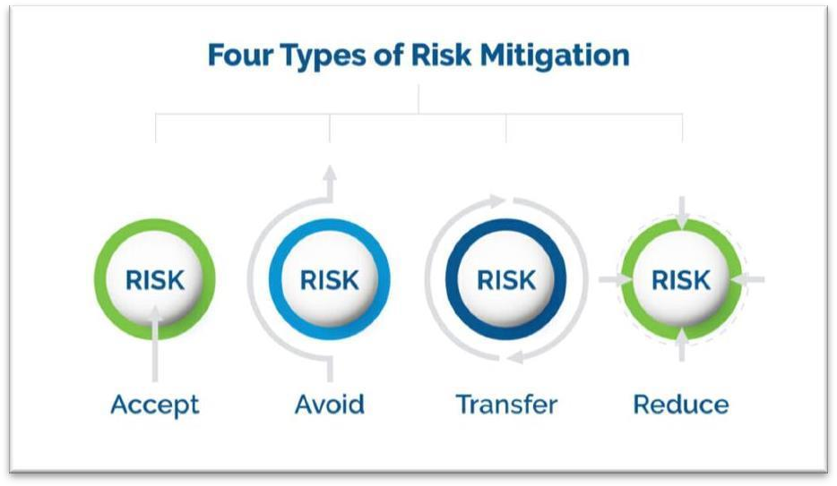

## Risk Mitigation

**Risk mitigation** refers to the strategies and actions taken to reduce or manage potential risks that could impact a project, business, or initiative. The goal is to minimize the likelihood of the risk occurring, reduce its impact, or ensure that the organization can respond effectively if it happens. In the context of project management, risk mitigation is an essential part of ensuring the project's success, particularly in unpredictable environments or where uncertainties are high.

### Steps in Risk Mitigation

#### Risk Identification:

* + The first step is identifying potential risks that might affect the project. This involves brainstorming, analyzing past projects, and considering potential uncertainties, such as technical, financial, legal, or external factors.
  + Tools like **SWOT analysis**, **brainstorming sessions**, and **risk registers** help in identifying risks.

#### Risk Assessment:

* + Once risks are identified, assess their **probability** (how likely they are to happen) and

**impact** (how severe their effects would be).

* + You can use a **Risk Matrix** to evaluate risks based on their likelihood and impact, which helps prioritize them for mitigation.

#### Risk Response Planning:

* + Develop strategies for each identified risk. These strategies may include:
* **Avoidance**: Changing the project plan to eliminate the risk.
* **Reduction (Mitigation)**: Taking steps to reduce the likelihood or impact of the risk (e.g., improving project controls or adding more resources).
* **Acceptance**: Acknowledging that the risk cannot be avoided or reduced and preparing to manage it if it happens.
* **Transfer**: Shifting the risk to a third party (e.g., through insurance or outsourcing).

#### Risk Monitoring

* + Continuously monitor the identified risks and any new risks that emerge during the project lifecycle.
  + Establish a process for regularly reviewing and updating the risk register, and adjusting mitigation strategies as necessary.

#### Communication:

It’s important to regularly communicate risks and mitigation strategies to all stakeholders. Keeping everyone informed ensures that everyone is prepared and can react promptly if risks materialize.

### Risk Mitigation Strategies

Here are some common risk mitigation strategies, which vary depending on the type of risk:

#### Technical Risks:

* + Use proven technologies.
  + Allocate extra time for testing.
  + Use prototypes or proof of concept to reduce uncertainty.

#### Schedule Risks:

* + Build buffer time into the project timeline.
  + Use agile methodologies to adjust and adapt to changes more quickly.
  + Keep tasks small and manageable to avoid delays.

#### Cost Risks:

* + Create realistic budgets with contingency funds.
  + Regularly monitor expenditures and adjust plans if necessary.
  + Use fixed-price contracts where appropriate to limit financial exposure.

#### Quality Risks:

* + Set clear quality criteria and ensure they are met.
  + Regularly test and review project deliverables.
  + Have quality control checks in place throughout the project.

#### Resource Risks:

* + Cross-train team members to reduce dependency on a few individuals.
  + Have backup plans for key resources or suppliers.
  + Make sure resource availability is properly planned and adjusted in case of changes.

#### External Risks (e.g., regulatory, market changes, natural disasters):

* + Stay informed about external factors that could affect the project (e.g., regulatory changes).
  + Diversify suppliers or have alternative plans if market conditions change.
  + Develop disaster recovery plans to respond to unexpected events like natural disasters.

# ACTIVITY-5

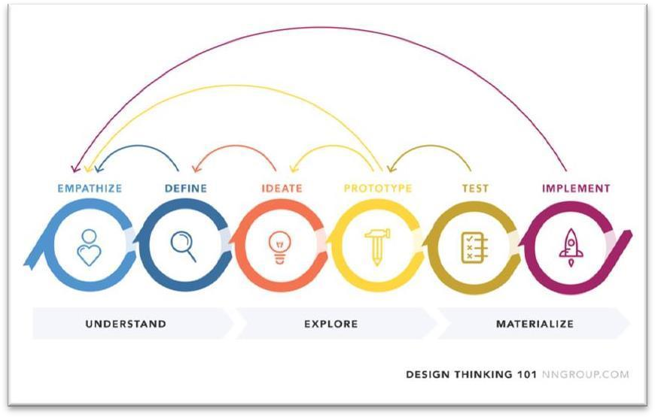

## Understand the process of design thinking

**Design Thinking** is a problem-solving methodology that focuses on understanding users, challenging assumptions, and redefining problems to identify alternative solutions. It is a human- centered approach widely used in product development, service design, and innovation. Design thinking involves collaboration, creativity, and iterative processes to create solutions that truly address the needs and pain points of users. Here’s an overview of the design thinking process:

### Empathize

* + **Goal**: Understand the user and their needs.
  + **Activities**: In this stage, the focus is on deeply understanding the people you’re designing for. This is done through qualitative research methods such as:
  + **Interviews** with users
  + **Observations** to see how people interact with the product or service
  + **Surveys** to gather more structured data
  + **Immersion** in the user’s environment to understand their challenges and experiences
  + **Outcome**: The goal is to gain insights into users’ emotions, pain points, needs, and desires, creating a deep empathy for their situation.

### Define

* + **Goal**: Define the problem clearly and in a user-centered way.
  + **Activities**: After gathering insights from the empathize phase, the next step is to synthesize the information into a clear problem statement, also known as a **Point of View (POV)**. This statement should focus on the user's needs and challenges.
  + Create **user personas** to represent the primary users and their key characteristics.
  + Write a **problem statement** or **design challenge** that defines what problem you are trying to solve in a human-centered way.
  + **Outcome**: A clear and concise problem statement that guides the ideation phase, making sure the team remains focused on solving real user needs.

### Ideate

* + **Goal**: Generate a wide range of ideas and solutions.
  + **Activities**: This phase encourages brainstorming, creativity, and exploration. It’s about breaking free from conventional thinking and considering many possible solutions, without judgment or limitation at first.
  + Use brainstorming techniques such as **Mind Mapping**, **SCAMPER**, or **Brainwriting**.
  + Encourage wild ideas, and combine and improve upon ideas.
  + Engage in **collaborative thinking** with team members, stakeholders, or even users to stimulate creativity.
  + **Outcome**: A diverse collection of ideas that can be explored further in the next stages. The best and most promising concepts will be selected for prototyping.

### Prototype

* + **Goal**: Build tangible representations of ideas to explore and test them.
  + **Activities**: Prototypes are simple, cost-effective, and quick models or drafts of the product or solution. These can range from paper sketches to digital mockups or working models.
  + **Low-fidelity prototypes**: Rough, low-cost models (like paper prototypes or wireframes).
  + **High-fidelity prototypes**: More refined, but still incomplete versions of the product.
  + **Iterative testing**: Prototypes are often tested on real users, and feedback is used to improve them.
  + **Outcome**: A physical or digital prototype that helps visualize ideas, generate feedback, and clarify the direction for further development.

### Test

* **Goal**: Test prototypes and refine the solution.
* **Activities**: Testing involves gathering feedback from real users to see how well the prototype meets their needs. The results from testing often lead to new insights and improvements.
* **User Testing**: Observing users interacting with the prototype to see if it solves the problem.
* **Feedback loops**: Collecting detailed feedback from users and stakeholders to identify what works and what doesn’t.
* **Refining the prototype**: Based on user feedback, prototypes are improved, iterated, and tested again.
* **Outcome**: The goal is to identify strengths and weaknesses in the prototype and refine it to better meet user needs.

### Application in Real-World Projects:

Design Thinking can be used in various industries:

* + **Product Development**: Creating user-friendly products that solve real problems.
  + **Service Design**: Designing new services or improving existing ones based on user needs.
  + **Business Innovation**: Helping businesses to innovate by focusing on human needs rather than just technological solutions.
  + **Healthcare**: Designing healthcare systems, patient care processes, or medical devices with the patient’s experience in mind.
  + **Education**: Creating learning environments or tools that engage and support students

# ACTIVITY-6

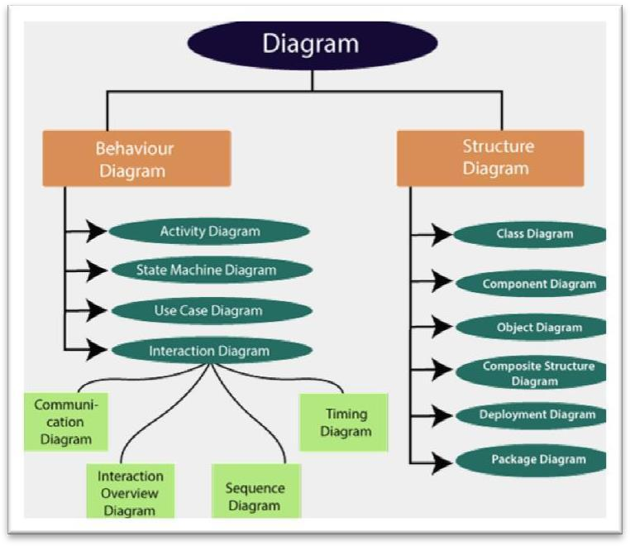

## Overview of UML

**Unified Modeling Language (UML)** is a standardized visual language used to model and design software systems. It provides a way to visualize, specify, construct, and document the artifacts of a software system, making it easier to understand and communicate complex designs.

### Purpose of UML

UML is primarily used to:

* + **Model** the structure and behavior of a system.
  + **Visualize** software designs to make them easier to understand.
  + **Document** system specifications to help developers and stakeholders understand the project.
  + **Standardize** software modeling to ensure consistency across teams and projects.

### UML Diagrams

UML diagrams can be broadly categorized into two types:

* + **Structural Diagrams**: Represent the static aspects of a system.
  + **Behavioral Diagrams**: Represent the dynamic aspects of a system.

#### Structural Diagrams:

These diagrams describe the structure or static aspects of a system, such as its components, classes, objects, and their relationships.

1. **Class Diagram**: Represents the classes in a system, their attributes, methods, and the relationships between classes (like inheritance, association, and aggregation).
2. **Object Diagram**: Represents instances of classes (objects) at a particular moment in time, showing their state and relationships.
3. **Component Diagram**: Shows how different components of a system interact, typically at a high level (e.g., software modules or subsystems).
4. **Deployment Diagram**: Illustrates the physical deployment of software components on hardware nodes, describing the system's architecture and its physical distribution.
5. **Package Diagram**: Represents how different classes or components are grouped into packages or namespaces.
6. **Composite Structure Diagram**: Describes the internal structure of a class and its collaboration with other classes or components.

#### Behavioral Diagrams:

These diagrams capture the dynamic or functional aspects of a system, showing how objects or components interact and change over time.

1. **Use Case Diagram**: Describes the system's functional requirements from a user's perspective, showing actors (users or other systems) and use cases (specific actions or interactions the system performs).
2. **Sequence Diagram**: Shows the sequence of messages exchanged between objects or components over time to accomplish a specific behavior or use case.
3. **Collaboration Diagram**: Focuses on the interactions between objects or components but emphasizes the structure and relationships between them.
4. **State Machine Diagram (State Diagram)**: Describes the states an object or component can be in and the transitions between these states based on events or conditions.
5. **Activity Diagram**: Represents workflows and business processes, showing how actions or operations flow through a system.
6. **Communication Diagram**: Similar to sequence diagrams but focuses more on the objects and their links, showing the flow of messages and their relationships.
7. **Interaction Overview Diagram**: Combines elements of activity diagrams and sequence diagrams to represent the flow of control between interacting objects and behaviors.

### UML Notations

Each UML diagram uses specific symbols to represent different elements, and understanding these notations is key to interpreting UML diagrams effectively:

* + **Classes**: Represented by rectangles with three compartments: the top for the class name, the middle for attributes, and the bottom for methods.
  + **Actors**: Represented by stick figures in use case diagrams, representing users or other systems that interact with the system.
  + **Objects**: Represented by rectangles with the object's name, type, and state.
  + **Associations**: Lines connecting objects or classes, with arrows indicating direction or cardinality (e.g., one-to-many, many-to-many).
  + **Messages**: Arrows in sequence diagrams representing communication between objects.
  + **States**: Rounded rectangles representing different states in state machine diagram

#### Benefits of UML

* + - **Standardized Language**: UML is a widely accepted, standardized modeling language, making it easier for developers, designers, and stakeholders to communicate.
    - **Improved Understanding**: It helps team members and stakeholders understand the design and functionality of a system.
    - **Documentation**: UML provides a clear, structured way to document system designs, which is crucial for both development and maintenance phases.
    - **Design Validation**: UML diagrams help in validating the design by allowing teams to simulate system behavior and interactions before implementation.
    - **Reuse and Refactoring**: UML helps in designing reusable components and refactoring complex systems by representing their structure and interactions visually.

### When to Use UML

UML is commonly used in:

* + **Software Design**: To model the structure, behavior, and interactions of complex systems.
  + **System Analysis**: To break down and understand system requirements, structure, and behavior.
  + **Communication**: To communicate design ideas and system architecture between stakeholders.
  + **Documentation**: For documenting and maintaining system designs throughout the software development lifecycle.

### UML Tools

There are many UML modeling tools available to create diagrams, such as:

* + Lucidchart
  + Microsoft Visio
  + StarUML
  + Enterprise Architect
  + Creately

# ACTIVITY-7

## The INVEST Model

The INVEST model is a guideline used in Agile software development to create high-quality user stories. It ensures that each user story is well-defined and ready for development. INVEST is an acronym that stands for:

1. Independent – The story should be self-contained and not dependent on other stories to be completed.
2. Negotiable – The details should be flexible and open to discussion rather than being a fixed contract.
3. Valuable – The story should deliver value to the user or customer.
4. Estimable – The team should be able to estimate the effort required to complete it.
5. Small – The story should be small enough to be completed within a single iteration or sprint.
6. Testable – The story should have clear acceptance criteria to verify that it is complete.

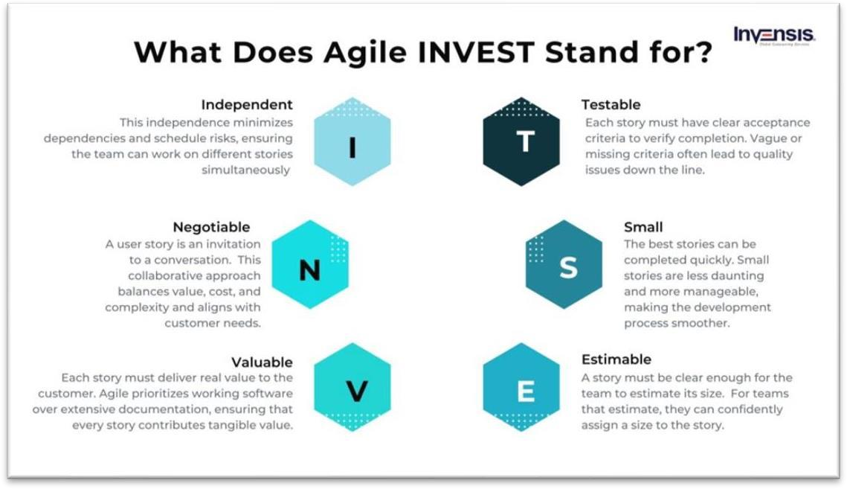

#### Why Use the INVEST Model?

* + Ensures better backlog grooming and prioritization.
  + Helps teams create well-defined stories that are easier to implement.
  + Improves communication and collaboration between team members.
  + Reduces risk by ensuring that each story is small, independent, and testable.

#### Main Characteristics of the INVEST Model

1. **Independent**
   * Each user story should be self-contained and not dependent on other stories.
   * This allows for flexible prioritization and parallel development.

#### Negotiable

* + User stories should not be rigidly defined but open for discussion and refinement.
  + This encourages collaboration between developers, product owners, and stakeholders.

#### Valuable

* + Every story must provide **clear business value** to the user or customer.
  + Avoid technical tasks that do not directly contribute to user benefits.

#### Estimable

* + The story should be clear enough for the team to **estimate** the effort required to complete it.
  + If a story is too vague or complex, it needs further breakdown or clarification.

#### Small

* + A user story should be **small enough** to be completed within a single sprint (typically 1-2 weeks).
  + Large stories (epics) should be split into smaller, more manageable tasks.

#### Testable

* + The story should have **clear acceptance criteria** to verify its completion.
  + If a story is not testable, it is likely too ambiguous and needs more refinement.

#### Advantages of the INVEST Model

1. **Improves Clarity & Understanding**
   * Ensures that user stories are well-defined and testable.
   * Reduces ambiguity, making it easier for teams to understand requirements.

#### Enhances Flexibility & Prioritization

* + Independent stories allow teams to rearrange priorities without dependencies.
  + Enables parallel development and faster progress.

#### Facilitates Collaboration & Negotiation

* + Encourages discussions between developers, product owners, and stakeholders.
  + Allows modifications to meet changing business needs.

#### Better Estimation & Planning

* + Ensures stories are small and estimable, improving sprint planning and velocity tracking.
  + Helps avoid oversized stories that slow down development.

#### Ensures High-Quality Deliverables

* + Enforces testability, ensuring that stories have clear acceptance criteria.
  + Leads to higher-quality software with fewer defects.

#### Disadvantages of the INVEST Model

1. **May Require Additional Effort**
   * Breaking down large tasks into smaller, independent stories takes time.
   * Teams need to refine and iterate on stories frequently.

#### Difficult to Maintain True Independence

* + Some features inherently depend on others, making true independence challenging.
  + Dependencies can still arise, requiring careful backlog management.

#### Not Always Suitable for Technical Tasks

* + The model is best suited for user-centric stories.
  + Technical stories (e.g., refactoring, performance optimization) may not directly provide value but are still essential.

#### Potential Overhead in Story Refinement

* + Ensuring that every story follows all six INVEST criteria can be time-consuming.
  + Over-refining stories might slow down the development process.

#### Applications of the INVEST Model

1. **Agile & Scrum Development**
   * Used in Scrum, Kanban, and other Agile frameworks to write better user stories.
   * Helps product owners and teams maintain a well-structured backlog.

#### Software Development Projects

* + Ensures that features are well-defined and testable before implementation.
  + Helps break down complex epics into manageable stories.

#### DevOps & Continuous Integration (CI/CD)

* + Supports iterative development, allowing frequent releases of small, valuable features.
  + Ensures automated testing can verify completed user stories.

#### Project Management & Business Analysis

* + Assists in structuring tasks for better estimation and prioritization.
  + Helps business analysts define clear requirements for development teams.

#### Investment Model: Theoretical Framework

1. **Introduction to Investment Models**

Investment models provide structured frameworks for understanding, analyzing, and predicting financial investment behaviors. These models integrate economic theories, mathematical principles, and empirical data to optimize investment decisions and manage risk.

#### Theoretical Foundations of Investment Models

Investment models are grounded in various economic and financial theories, including:

* + **Modern Portfolio Theory (MPT):** Developed by Harry Markowitz, this theory emphasizes diversification to optimize returns while minimizing risk.
  + **Capital Asset Pricing Model (CAPM):** A model that determines the expected return of an asset based on its risk relative to the market (systematic risk).
  + **Efficient Market Hypothesis (EMH):** Suggests that asset prices fully reflect all available information, making it impossible to consistently achieve above-average returns.
  + **Arbitrage Pricing Theory (APT):** A multi-factor model that explains asset returns based on various macroeconomic and firm-specific factors.
  + **Behavioral Finance Models:** Challenge traditional finance theories by incorporating psychological biases and investor behavior in decision-making.

#### Classification of Investment Models

Investment models can be broadly classified into:

#### Deterministic vs. Stochastic Models:

* + **Deterministic Models:** Provide fixed outcomes based on input variables.
  + **Stochastic Models:** Incorporate randomness and probability to reflect market uncertainties.

#### Static vs. Dynamic Models:

* + **Static Models:** Analyze investments at a single point in time.
  + **Dynamic Models:** Consider the evolution of investments over time.

#### Qualitative vs. Quantitative Models:

* + **Qualitative Models:** Rely on expert judgment and qualitative factors.
  + **Quantitative Models:** Use mathematical and statistical techniques for investment decision-making.

#### Components of an Investment Model

An investment model typically consists of:

* + **Risk Assessment:** Measures volatility, beta, or Value-at-Risk (VaR).
  + **Return Estimation:** Forecasts potential gains based on historical data and economic indicators.
  + **Asset Allocation Strategies:** Determines optimal portfolio composition.
  + **Optimization Techniques:** Uses algorithms such as Markowitz optimization, Monte Carlo simulations, or machine learning models to enhance decision-making.

#### Practical Applications of Investment Models

Investment models are applied in various domains, including:

* + **Portfolio Management:** Allocating assets to maximize returns for a given risk level.
  + **Risk Management:** Identifying and mitigating potential financial risks.
  + **Algorithmic Trading:** Using automated models for real-time investment decisions.
  + **Valuation Models:** Assessing fair market value of assets and securities.

# ACTIVITY-8

## Architectural Styles

Architectural styles define **how components of a system interact**, ensuring maintainability, scalability, and efficiency. Below is an **in-depth exploration** of various architectural styles, their advantages, disadvantages, and use cases.

#### 1️.Layered Architecture (N-Tier Architecture)

**Concept**: Organizes software into separate layers, each handling specific functionality.

#### Layers:

* **Presentation Layer (UI)** – Handles user interactions
* **Business Logic Layer** – Implements core functionality
* **Data Access Layer** – Manages database operations

#### Adavantages

Separation of concerns (each layer focuses on a specific task) Easier to test and maintain

Common in enterprise applications

#### Disadvantages

Performance overhead due to multiple layers

Tight coupling between layers can slow down changes

#### Use Cases:

Web applications (e.g., MVC frameworks like Django, Spring) Enterprise software

#### Client-Server Architecture

**Concept**: A **client** requests services from a **server**, which processes and responds.

#### Types:

* **Thin Client** – Most processing is done on the server
* **Thick Client** – Some processing is done on the client

#### Adavanatges

Centralized control and security Can support multiple clients

#### Disadvantages

Server can become a bottleneck Single point of failure

#### Use Cases:

Web applications (e.g., browsers and web servers) Database systems (e.g., MySQL, PostgreSQL)

#### Microservices Architecture

**Concept**: Breaks an application into **small, independent services** that communicate via APIs.

#### Characteristics:

* Each service has **its own database**
* Services are loosely coupled and independently deployable

#### Advantages

Highly scalable and flexible

Faster development with smaller teams

Technology-agnostic (different services can use different tech stacks)

#### Disadvantages

Complex deployment and orchestration Requires API management and service discovery

#### Use Cases:

Large-scale applications (Netflix, Amazon, Uber)

Cloud-native applications (AWS Lambda, Kubernetes-based systems)

#### Monolithic Architecture

**Concept**: The entire application is developed as a **single unit**, with all components tightly integrated.

#### Advantages

Simple to develop and deploy

Easier debugging due to a single codebase

#### Disadvantage

* Hard to scale

Difficult to maintain as the application grows

#### Use Cases:

Small to medium applications (Django, Ruby on Rails) Startups developing an MVP

#### 5️⃣Event-Driven Architecture

**Concept**: Components communicate through **events**, allowing asynchronous processing.

#### Types:

* **Pub-Sub Model** – Events are published and multiple subscribers react
* **Event Streaming** – Continuous data flow (Kafka, RabbitMQ)

#### Adavantages

Highly scalable and real-time processing Decoupled components for flexibility

#### Disadvantages

Debugging is complex

Requires event handling mechanisms

#### Use Cases:

IoT applications (sensor data processing)

Real-time applications (stock trading, messaging apps)

#### Service-Oriented Architecture (SOA)

**Concept**: Applications are built as a collection of **reusable services** that communicate over a network.

#### Difference from Microservices:

* + SOA services are **larger and more dependent** than microservices.
  + Uses **ESB (Enterprise Service Bus)** for communication.

#### Advantages

Encourages reusability

Works well in distributed environments

#### Disadvantages

Performance overhead due to network communication Requires strong governance

#### Use Cases:

Banking and financial systems Large enterprise applications

#### Peer-to-Peer (P2P) Architecture

**Concept**: Each node in the network acts as both **client and server**.

#### Advantages

No central point of failure Highly scalable and fault-tolerant

#### Disadvantages

Security risks due to lack of central control

Hard to manage node discovery and communication

#### Use Cases:

File-sharing networks (BitTorrent) Blockchain and cryptocurrencies

#### Pipe-and-Filter Architecture

**Concept**: Data is processed in **sequential steps**, where each step (filter) transforms the input before passing it to the next.

#### Adavantages

Easy to parallelize and scale

Modular design (each filter can be reused)

#### Disadvantages

High latency if too many filters are involved Debugging can be difficult

#### Use Cases:

UNIX shell commands (ls | grep txt | sort)

Compiler design (Lexical Analysis → Parsing → Code Generation)

1. **Model-View-Controller (MVC) Architecture Concept**: Separates concerns into three layers:

**Model** – Handles data and logic

**View** – Manages UI presentation

**Controller** – Manages user interactions

#### Advantages

Improves code organization and reusability Supports multiple user interfaces

#### Disadvantages

Complexity increases as the application grows Requires careful design to avoid tight coupling

#### Use Cases:

Web frameworks (React, Angular, Django, Rails) Desktop applications

#### Space-Based Architecture (Cloud-Native)

**Concept**: Distributes the workload across multiple nodes to prevent bottlenecks.

**Used in**: Scalable, cloud-native applications.

#### Advantages

High availability and fault tolerance Suitable for unpredictable workloads

#### Disadvantages

Complex to implement and maintain Not suitable for small-scale applications

#### Use Cases:

High-traffic e-commerce platforms Large-scale cloud applications

**Comparison Table of Architectural Styles**

|  |  |  |  |  |
| --- | --- | --- | --- | --- |
| **Architecture Style** | **Scalability** | **Complexity** | **Performance** | **Use Case Example** |
| **Layered** | Moderate | Low | Medium | Web Apps, Enterprise Systems |
| **Client-Server** | Moderate | Low | High | Web Services, Databases |
| **Microservices** | High | High | High | Netflix, Uber, Cloud Apps |
| **Monolithic** | Low | Low | High | Small MVPs, Simple Web Apps |
| **Event-Driven** | High | High | High | IoT, Real-Time Systems |
| **SOA** | Moderate | High | Medium | Banking, Large Enterprises |
| **P2P** | High | High | High | Blockchain, File Sharing |
| **Pipe-Filter** | Moderate | Medium | Low | Compilers, Streaming |
| **MVC** | Moderate | Medium | Medium | Web and Mobile Apps |
| **Space-Based** | High | High | High | Cloud-Native, E- Commerce |

# ACTIVITY-9

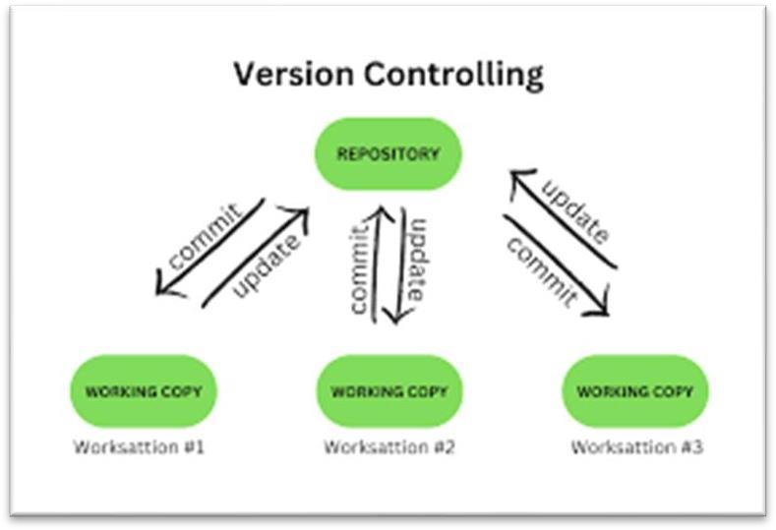

## Version Control

Version control is a system that records changes to files over time, allowing multiple people collaborate efficiently while keeping track of modifications, reverting to previous versions, and resolving conflicts.

#### Types of Version Control Systems (VCS)

1. **Local Version Control**
   * Stores changes on a single computer.
   * Requires manual backups and versioning.
   * Example: Copying files with different names (e.g., file_v1.txt, file_v2.txt).

#### Centralized Version Control (CVCS)

* + Uses a single central repository.
  + Developers pull and push changes from/to the server.
  + If the server fails, all history can be lost.
  + Examples: **Subversion (SVN), Perforce, CVS.**

#### Distributed Version Control (DVCS)

* + Every developer has a full copy of the repository.
  + Enables offline work and redundancy.
  + Examples: **Git, Mercurial.**

#### Why is a Version Control System (VCS) Important?

Version Control Systems are essential for managing code, documents, and project files efficiently. They provide a structured way to track changes, collaborate, and prevent data loss. Here’s why they are crucial:

#### Tracks Changes & Maintains History

* + Every modification is recorded, allowing you to see who made changes and why.
  + You can revert to an older version if something goes wrong.

#### Enables Collaboration

* + Multiple developers can work on the same project simultaneously.
  + Prevents overwriting each other’s changes.
  + Branching allows team members to work on different features independently.

#### Prevents Data Loss

* + If a file is accidentally deleted or corrupted, you can restore it from version history.
  + Distributed Version Control (like Git) ensures multiple copies exist, reducing risks.

#### Manages Conflicts

* + If two people edit the same file, a VCS detects conflicts and provides tools to merge them.
  + Ensures that everyone is working with the latest version of the code.

#### Supports Experimentation & Parallel Development

* + Developers can create **branches** to work on new features without affecting the main codebase.
  + If a feature doesn’t work, the branch can be discarded without impacting the main project.

#### Increases Project Transparency

* + Developers can see the evolution of a project over time.
  + Helps in debugging and identifying when and where bugs were introduced.

#### Automates Deployment & Integration

* + VCS can be integrated with Continuous Integration/Continuous Deployment (CI/CD) pipelines.
  + Ensures that tested and approved changes are deployed efficiently.

#### Purpose of Version Control

A **Version Control System (VCS)** is used to manage changes to files, track modifications, and enable collaboration among multiple users. It is essential for maintaining the integrity and efficiency of software development and other projects

#### Tracking Changes

* + Keeps a complete history of modifications to files.
  + Allows developers to see what was changed, when, and by whom.
  + Helps in debugging by identifying when a bug was introduced.

#### Collaboration & Teamwork

* + Enables multiple people to work on the same project without overwriting each other’s work.
  + Provides a structured way to merge changes and resolve conflicts.
  + Ensures everyone is working on the latest version of the files.

#### Preventing Data Loss

* + Stores a complete backup of the project, allowing recovery from accidental deletions or corruption.
  + Distributed version control (e.g., Git) ensures multiple copies exist, reducing risks.

#### Branching & Parallel Development

* + Developers can create separate branches to work on new features or fixes without affecting the main code.
  + Changes can be tested and reviewed before merging into the main branch.
  + Different teams can work on different features simultaneously.

#### Reverting to Previous Versions

* + If a mistake is made, the project can be rolled back to an earlier version.
  + Ensures stability by allowing developers to undo unintended changes.

#### Managing Releases & Deployments

* + Version control helps manage different versions of software releases.
  + Supports automation in **Continuous Integration/Continuous Deployment (CI/CD)**

pipelines.

#### Transparency & Documentation

* + Provides a clear history of changes, making it easier to understand how and why modifications were made.
  + Helps new team members onboard quickly by reviewing past changes.

# ACTIVITY-10

## Containerization

#### What is Containerization?

Containerization is a lightweight form of virtualization that packages an application and its dependencies together into an isolated unit called a **container**. This ensures that applications run consistently across different environments, whether on a developer's laptop, a test server, or in production.

Containers provide an **isolated, portable, and efficient** way to deploy applications without worrying about compatibility issues between different environments.

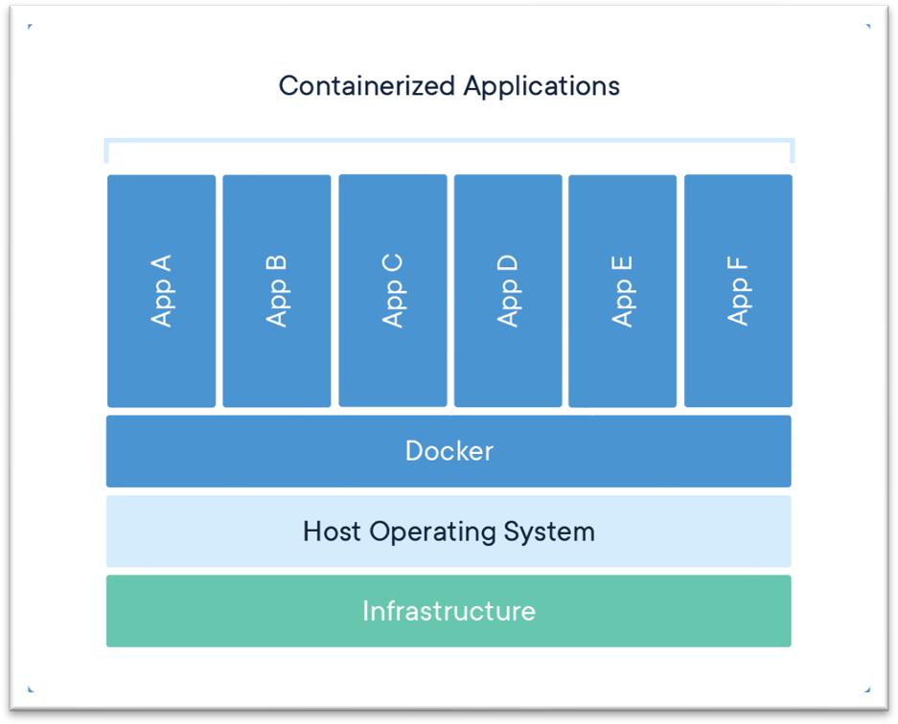

#### How Does Containerization Work?

* + Containers use the **host operating system's kernel** but keep applications and their dependencies separate from other processes.
  + Unlike virtual machines (VMs), which require a full OS for each instance, containers share the same OS kernel, making them **lightweight and fast**.

#### Popular Containerization Tools:

* + - **Docker** (most widely used)
    - **Podman**
    - **LXC (Linux Containers)**
    - **Containerd**

1. **Lightweight & Efficient**

Containers share the **host OS kernel**, reducing overhead compared to virtual machines (VMs). They require fewer system resources, leading to **faster startup times** and better performance.

#### Portability

A containerized application runs **consistently across any environment** (development, testing, production).

Works on **any platform** that supports containers, including **on-premises, cloud, and hybrid environments**.

#### Isolation

Each container runs in its **own isolated environment**, preventing conflicts between applications. Dependencies, libraries, and runtime environments are packaged inside the container.

#### Scalability & Orchestration

Supports **horizontal scaling**—containers can be replicated and distributed easily. Works seamlessly with **Kubernetes** for **automated scaling and orchestration**.

#### Rapid Deployment & Start-up

Containers start **in seconds**, unlike VMs, which take minutes.

Helps in **Continuous Integration/Continuous Deployment (CI/CD)** pipelines for faster application updates.

#### Security & Access Control

Containers **isolate applications**, reducing security risks from other processes.

Additional security layers can be applied using **RBAC (Role-Based Access Control)** and network policies.

#### Ephemeral & Immutable

Containers are **stateless and ephemeral**—they can be easily created, destroyed, or replaced. Immutable infrastructure ensures that deployments are **consistent and reproducible**.

#### Persistent Storage Support

While containers are ephemeral, **volumes and persistent storage** can be attached to store important data.

Solutions like **Docker Volumes, Kubernetes Persistent Volumes (PV), and cloud storage** help retain data.

#### DevOps & CI/CD Friendly

Containers integrate well with **DevOps workflows** for automated builds, testing, and deployment. Compatible with **Docker, Kubernetes, Jenkins, GitHub Actions, and other CI/CD tools**.

#### Microservices & Cloud-Native Support

Containers enable **microservices architecture**, allowing applications to be broken into smaller, independent services.

Fully compatible with **cloud platforms like AWS, Azure, and Google Cloud** for scalable deployments.

# ACTIVITY-11

## Integration Testing

#### What is Integration Testing?

Integration Testing is a **software testing technique** where individual modules or components are tested together to verify that they work correctly as a group. It helps identify issues in **data flow, API communication, and module interactions** before system testing.

* **Performed After**: Unit Testing
* **Performed Before**: System Testing

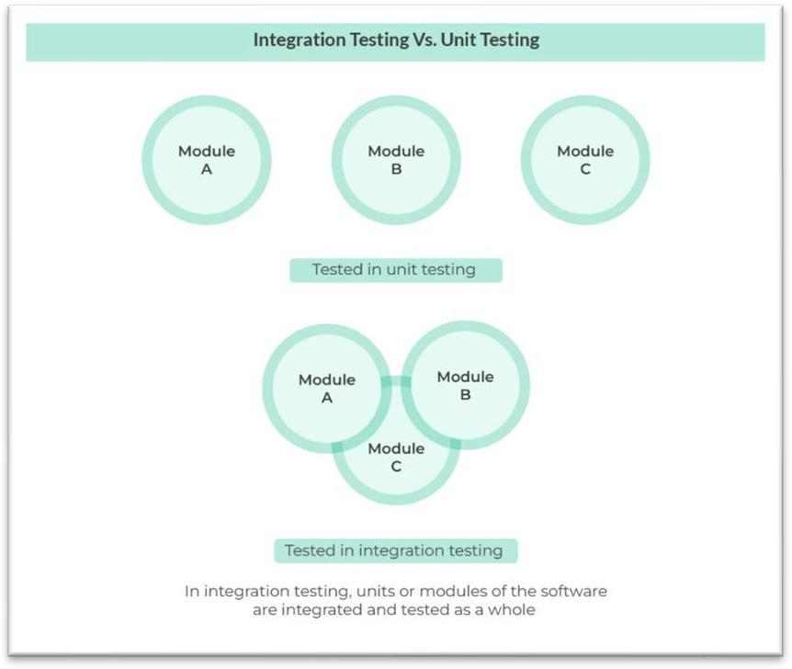

#### Types of Integration Testing

1. **Big Bang Integration Testing**

**Definition**: All components or modules are integrated simultaneously and tested as a single unit.

**Use Case**: Suitable for small applications with fewer modules.

#### Advantages:

Simple to implement for small projects. Entire system tested at once.

#### Disadvantages:

Difficult to isolate errors.

High debugging effort since everything is tested at once. Not suitable for large applications.

#### Incremental Integration Testing

**Definition**: Modules are integrated and tested **step-by-step** rather than all at once.

#### Types of Incremental Testing:

1. **Top-Down Integration Testing**
   * **How it works**: Testing starts from **higher-level** modules and moves **downward**.
   * **Use Case**: Useful when the system follows a **hierarchical structure**.

#### Advantages:

Identifies high-level logic issues early. Critical modules are tested first.

#### Disadvantages:

Lower-level modules might be incomplete, requiring **stubs** (dummy functions). Not suitable for applications where bottom-level modules are critical.

#### Bottom-Up Integration Testing

* + **How it works**: Testing starts from **lower-level** modules and moves **upward**.
  + **Use Case**: Used when low-level functionalities are well-defined first.

#### Advantages:

Identifies defects in low-level modules early.

No need for stubs, as lower modules are tested first.

#### Disadvantages:

High-level defects may remain undetected until later stages. UI testing is delayed since upper modules come last.

#### Sandwich (Hybrid) Integration Testing

* + **How it works**: Combines **Top-Down and Bottom-Up approaches**.
  + **Use Case**: Used for complex systems where **both high and low-level modules** are important.

#### Advantages:

Balances **high-level logic and low-level functionalities**. Faster error detection across all levels.

* + **Disadvantages**: Complex to manage.

Requires more effort in test design.

#### Interface Testing

**Definition**: Tests the communication between different modules, APIs, or systems.

#### Use Case: Used in microservices, API testing, and third-party integrations.

* + **Advantages**:

Ensures **correct data exchange** between modules. Identifies **communication failures** early.

#### Disadvantages:

Requires **mocking or stubbing** if real services are unavailable. API changes may break integration tests.

#### Regression Integration Testing

**Definition**: Ensures **new updates** do not break existing functionalities.

**Use Case**: Used in **CI/CD pipelines** where new changes are frequently deployed.

#### Advantages:

Prevents **new bugs** from affecting previous features. Automatable with tools like **Selenium, Postman, and JUnit**.

#### Disadvantages:

Can be time-consuming if not automated.

Frequent changes may lead to **test maintenance overhead**.

#### Key Reasons for Integration Testing

1. **Detect Interface Issues Early**

Software modules often interact through **APIs, databases, or function calls**. Errors in these interactions can lead to **data loss, miscommunication, or crashes**. Integration testing helps identify and resolve these problems early.

#### Validate Data Flow Between Modules

Data passed between modules should remain **consistent and accurate**.

Incorrect data flow can lead to **functional failures, security vulnerabilities, or corrupted records**.

Example: A banking app should ensure correct balance updates when transferring funds between accounts.

#### Identify Bugs That Unit Testing Can’t Catch

Unit testing checks **individual modules**, but it **doesn’t test their interaction** with other components.

Bugs often arise **only when modules are combined**, such as:

* + Incompatible data formats between modules
  + Unexpected API failures
  + Database connection errors

#### Ensure Seamless Third-Party Integration

Modern applications rely on **external APIs and third-party services** (e.g., payment gateways, cloud storage).

Integration testing verifies that these services work correctly with the application. Example: A shopping website must ensure that **PayPal or Stripe payments** are processed correctly.

#### Support Microservices & Distributed Systems

In **microservices architecture**, each service is independent but needs to communicate with others. Integration testing ensures that **services interact correctly**, avoiding failures in real-world deployments.

Example: In an **e-commerce system**, the **order service, inventory service, and payment service**

must work together.

#### Improve System Reliability & Performance

Prevents **unexpected crashes and downtime** due to module failures. Ensures the system performs well **under load and real-world conditions**.

Example: In cloud-based applications, integration testing helps ensure smooth **scalability**.

#### Essential for CI/CD & Agile Development

Integration testing is crucial in **Continuous Integration/Continuous Deployment (CI/CD)**

pipelines.

Ensures that frequent changes and updates don’t break existing functionality. Automated integration tests help detect failures early, **speeding up development cycles**.

# ACTIVITY-12

## Metrics

Software testing metrics are quantitative measurements used to assess the effectiveness, quality, and progress of the testing process. They help teams make data-driven decisions and improve software reliability.

#### Key Uses of Software Metrics

1. **Measuring Software Quality**

Helps evaluate **code reliability, maintainability, and performance**. Identifies **defect density, code complexity, and test coverage**.

Example: **Defect Density** = (Total Defects / Lines of Code)

#### Tracking Testing Effectiveness

Measures how well the testing process detects defects. Helps identify **missed test cases** and improve coverage.

Example: **Test Pass Rate** = (Passed Tests / Total Tests) × 100

#### Improving Development Efficiency

Tracks the **productivity** of development teams.

Helps optimize **coding standards, bug fixes, and code reviews**. Example: **Code Churn Rate** (frequency of code changes over time)

#### Ensuring Project Progress & Timelines

Tracks software development **progress and deadlines**. Helps in **resource allocation and risk management**.

Example: **Velocity in Agile** (story points completed per sprint)

#### Enhancing Customer Satisfaction

Ensures that software meets **user expectations and performance standards**. Helps detect and fix **critical issues before release**.

Example: **Customer-Reported Defect Rate** = (Bugs Reported by Users / Total Bugs)

#### Supporting Decision-Making

Provides **data-driven insights** for management and stakeholders.

Helps in **predicting project risks and making process improvements**. Example: **Mean Time to Repair (MTTR)** (average time to fix a defect)

#### Optimizing Resources & Costs

Helps **reduce development and testing costs** by optimizing workflows. Identifies **bottlenecks and inefficiencies** in the development process.

Example: **Cost Per Defect** = (Total Testing Cost / Number of Defects Found)

#### Classification of Software Metrics

Software metrics are categorized based on their purpose and the aspect of software development they measure. The main classifications include **Product Metrics, Process Metrics, and Project Metrics**.

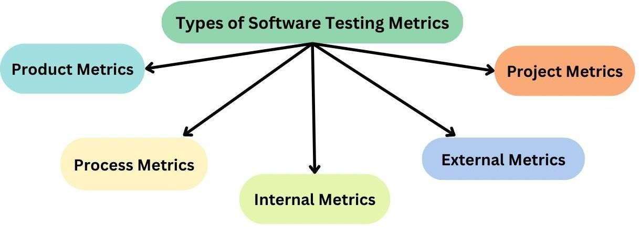

#### Product Metrics

These metrics measure the **quality and characteristics of the software product** itself.

#### Key Types:

* + **Size Metrics** – Measures code size (e.g., Lines of Code (LOC), Function Points).
  + **Complexity Metrics** – Measures the difficulty of the code (e.g., Cyclomatic Complexity).
  + **Quality Metrics** – Evaluates software reliability, maintainability, and security (e.g., Defect Density, Code Coverage).
  + **Performance Metrics** – Assesses speed, efficiency, and resource usage (e.g., Response Time, Throughput).

#### Use Case: Helps improve software quality, reliability, and maintainability.

1. **Process Metrics**

These metrics track the **efficiency of the software development and testing process**. **Key Types:**

* + **Defect Metrics** – Measures defect detection and removal efficiency (e.g., Defect Detection Rate, Defect Removal Efficiency).
  + **Test Metrics** – Evaluates testing progress and coverage (e.g., Test Pass Rate, Test Execution Rate).
  + **Code Review Metrics** – Tracks review efficiency (e.g., Code Review Defect Rate).
  + **Build & Deployment Metrics** – Measures CI/CD efficiency (e.g., Build Success Rate, Deployment Frequency).

#### Use Case: Helps in process improvement, reducing defects, and increasing development speed.

1. **Project Metrics**

These metrics focus on **project planning, resource management, and team productivity**. **Key Types:**

* + **Effort & Cost Metrics** – Measures development effort and budget (e.g., Effort Variance, Cost Per Defect).
  + **Schedule Metrics** – Tracks project timelines (e.g., Schedule Variance, Sprint Velocity).
  + **Team Productivity Metrics** – Assesses developer and tester productivity (e.g., Bugs Fixed Per Developer, Code Commit Frequency).
  + **Risk Metrics** – Identifies potential risks (e.g., Change Failure Rate, Risk Exposure).

#### Use Case: Helps in project tracking, resource allocation, and risk management.

1. **Advanced Metrics (Agile & DevOps-Specific)**

These are modern metrics used in **Agile, DevOps, and CI/CD** environments.

#### Key Types:

* + **Lead Time** – Time taken from code commit to production.
  + **Deployment Frequency** – How often new updates are deployed.
  + **Mean Time to Detect (MTTD)** – Time taken to identify defects.
  + **Mean Time to Repair (MTTR)** – Time taken to fix defects.

#### Use Case: Helps in continuous improvement, faster releases, and reliability in Agile/DevOps. Key Characteristics of Software Metrics

1. **Reliability**

The metric should produce **consistent** and **repeatable** results over time.

Example: A **defect density metric** should give similar values when applied to different modules of similar complexity.

#### Validity

The metric should measure what it is intended to measure.

Example: **Code Coverage** should accurately reflect the percentage of code executed during testing.

#### Measurability

The metric should be **quantifiable** and not based on subjective opinions.

Example: **Mean Time to Detect (MTTD)** is measured in hours/days, making it objective.

#### Simplicity & Understandability

A good metric should be **easy to interpret and communicate**.

Example: **Test Pass Percentage** = (Passed Test Cases / Total Executed Cases) × 100 is simple to understand.

#### Objectivity

The metric should not be influenced by personal opinions or biases.

Example: **Function Points (FP)** measure software size **independent** of coding style or language.

#### Comparability

The metric should allow comparisons between **different projects, teams, or time periods**. Example: **Bug Fix Rate** can be compared across multiple sprints to assess improvement.

#### Actionability

The metric should provide **insights that lead to improvements**.

Example: If **Defect Leakage** (bugs found in production) is high, testing strategies can be improved.

#### Scalability

The metric should work for both **small and large** projects without losing effectiveness. Example: **Code Churn Rate** should scale well for small and enterprise-level projects.

#### Cost-Effectiveness

The effort required to collect and analyze the metric should not outweigh its benefits. Example: **Automated test execution metrics** provide valuable insights with minimal manual effort

#### Timeliness

The metric should provide insights **at the right time** for decision-making. Example: **Sprint Velocity** helps Agile teams adjust workload for upcoming sprints.

#### Application of Metrics in Different Domains

* 1. **Software Development & Maintenance Metrics Used:**
     + **Cyclomatic Complexity** (Measures code complexity for maintainability)
     + **Lines of Code (LOC)** (Measures software size)
     + **Defect Density** (Measures quality of code)

#### Application:

* + - Helps in **code refactoring** to improve maintainability.
    - Identifies **high-risk modules** in large-scale applications.
    - Used in software like **Microsoft Office, Linux Kernel**, and enterprise applications.

#### Agile and DevOps Development Metrics Used:

* + - **Velocity** (Measures team's productivity per sprint)
    - **Sprint Burndown Chart** (Tracks progress of tasks)
    - **Lead Time & Cycle Time** (Measures development speed)

#### Application:

* + - Used in **Scrum-based Agile development** for sprint planning.
    - Helps in **continuous integration and continuous deployment (CI/CD)** pipelines.
    - Applied in **JIRA, Azure DevOps, GitLab CI/CD** to track Agile team performance.

#### Software Testing and Quality Assurance Metrics Used:

* + - **Test Coverage** (Percentage of code tested)
    - **Defect Removal Efficiency (DRE)** (Effectiveness of bug fixing)
    - **Defect Leakage** (Bugs found after release)

#### Application:

* + - Helps in ensuring **high code coverage** for critical systems (e.g., banking, healthcare).
    - Applied in **automated testing frameworks** like Selenium and JUnit.
    - Used by **Google, Amazon, and Apple** to maintain software reliability.

#### Security and Risk Management Metrics Used:

* + - **Vulnerability Density** (Security flaws per LOC)
    - **Mean Time to Detect (MTTD)** (Time taken to detect a security issue)
    - **Mean Time to Recover (MTTR)** (Time taken to fix a security issue)

#### Application:

* + - Used in **cybersecurity monitoring** for detecting vulnerabilities in web applications.
    - Applied in **penetration testing and compliance audits** (e.g., OWASP, ISO 27001).

#### Critical for banking, government, and cloud security (AWS, Azure, Google Cloud).

* 1. **Cloud and Web Applications Metrics Used:**
     + **Response Time** (Measures speed of web services)
     + **Availability (Uptime %)** (Ensures system reliability)
     + **Error Rate** (Number of failed requests)

#### Application:

* + - Ensures **high uptime for cloud services** like AWS, Google Cloud, Microsoft Azure.
    - Used in **web performance monitoring** (e.g., New Relic, Datadog).
    - Applied in SaaS platforms like **Zoom, Slack, and Shopify** for user experience optimization.

#### Embedded Systems and IoT Applications Metrics Used:

* + - **Real-time Performance Metrics** (Latency, response time)
    - **Energy Efficiency Metrics** (Power consumption in IoT devices)
    - **Failure Rate (MTBF, MTTR)** (Reliability in critical systems)

#### Application:

* + - Used in **automotive software (Tesla, BMW, Airbus avionics systems)**.
    - Helps optimize **IoT devices like smart home assistants, medical devices**.
    - Applied in **edge computing and robotics** to ensure low-latency responses.

# ACTIVITY-13

## Audit Types

Audits help ensure compliance, security, efficiency, and quality in software development, IT systems, and business processes. Different types of audits focus on various aspects of the system.

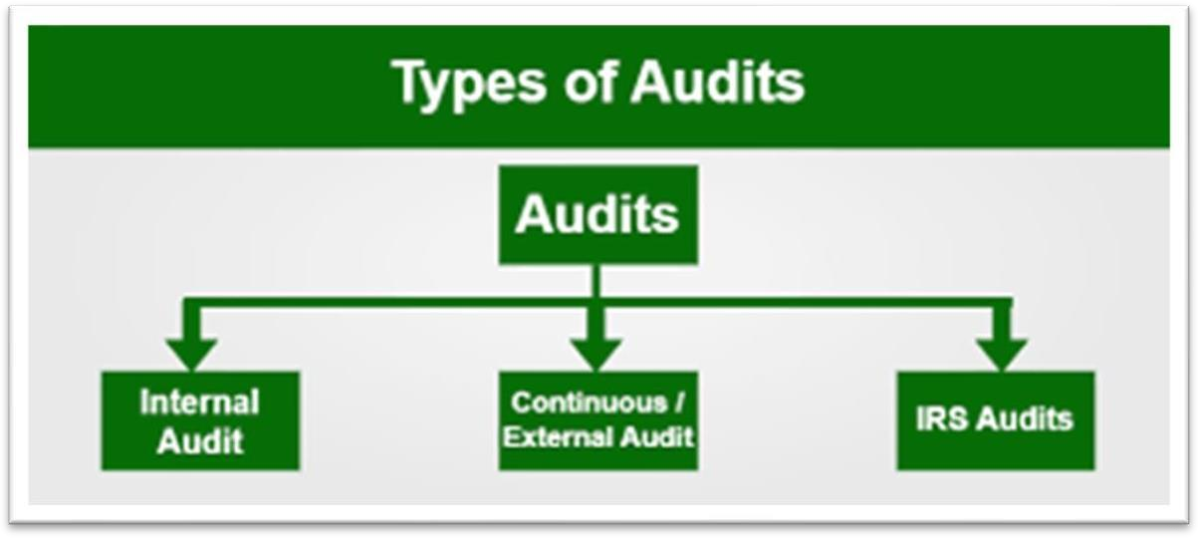

#### Product Audit

**Purpose:** Ensures the **software product meets requirements** for functionality, performance, and usability.

**Example:** Testing an **e-commerce website** to verify that the checkout process works correctly.

#### Key Areas Audited:

* + Functionality testing
  + Performance and load testing
  + User experience (UX) testing
  + Defect tracking

#### Process Audit

**Purpose:** Examines **software development processes** to ensure they follow best practices and industry standards.

**Example:** Reviewing an **Agile team's sprint process** to check if tasks are completed as planned.

#### Key Areas Audited:

* + Software Development Life Cycle (SDLC) compliance
  + Agile/Scrum or DevOps practices
  + CI/CD pipeline efficiency
  + Code review process

#### Compliance Audit

**Purpose:** Ensures **adherence to laws, industry regulations, and security policies**.

**Example:** Checking if a **healthcare app** follows **HIPAA** regulations for patient data protection.

#### Key Areas Audited:

* + GDPR, HIPAA, PCI-DSS, ISO 27001 compliance
  + Data privacy policies
  + Security controls
  + Access control and authentication

#### Security Audit

**Purpose:** Identifies **cybersecurity risks and vulnerabilities** in software and IT infrastructure.

**Example:** Running **penetration tests** on a banking application to find security weaknesses.

#### Key Areas Audited:

* + Application security (SQL injection, XSS)
  + Network security (firewalls, encryption)
  + Authentication & authorization
  + Security patch management

#### Code Audit (Source Code Review)

**Purpose:** Reviews **source code for quality, security, and maintainability**.

**Example:** Using **SonarQube** to analyze **code complexity and security vulnerabilities** in a Python project.

#### Key Areas Audited:

* + Code quality and readability
  + Security vulnerabilities in code
  + Performance optimization
  + Coding standard compliance

#### Configuration Audit

**Purpose:** Examines **software, system, and infrastructure configurations** for consistency and security.

**Example:** Checking **Docker container configurations** to ensure secure deployment.

#### Key Areas Audited:

* + System and application settings
  + Server and database configurations
  + Version control and environment consistency
  + Compliance with baseline configurations

#### IT Audit (Information Systems Audit)

**Purpose:** Evaluates **IT infrastructure, data security, and system reliability**. **Example:** Auditing a **cloud-based system** for security and operational risks. **Key Areas Audited:**

* + IT governance policies
  + Network security and access controls
  + Backup and disaster recovery plans
  + Software license management

#### Financial Audit (Software Cost Audit)

**Purpose:** Reviews **budgeting, cost estimation, and financial efficiency** in software development.

**Example:** Checking a **software development project’s budget** to prevent overspending.

#### Key Areas Audited:

* + Software development cost analysis
  + Licensing fees and vendor contracts
  + ROI (Return on Investment) evaluation
  + Financial fraud prevention

#### Performance Audit

**Purpose:** Assesses **software/system performance, speed, and resource usage**. **Example:** Running **load testing** on a website to ensure it handles **high traffic** efficiently.

#### Key Areas Audited:

* + Response time and latency
  + System scalability and resource utilization
  + Database performance
  + Bottlenecks in application performance

#### Vendor Audit (Third-Party Audit)

**Purpose:** Evaluates **external service providers and third-party vendors** for compliance and reliability.

**Example:** Auditing a **cloud hosting provider** before migrating sensitive business data.

#### Key Areas Audited:

* + Vendor security practices
  + Service Level Agreement (SLA) compliance
  + Data privacy and protection policies
  + Third-party risk assessment